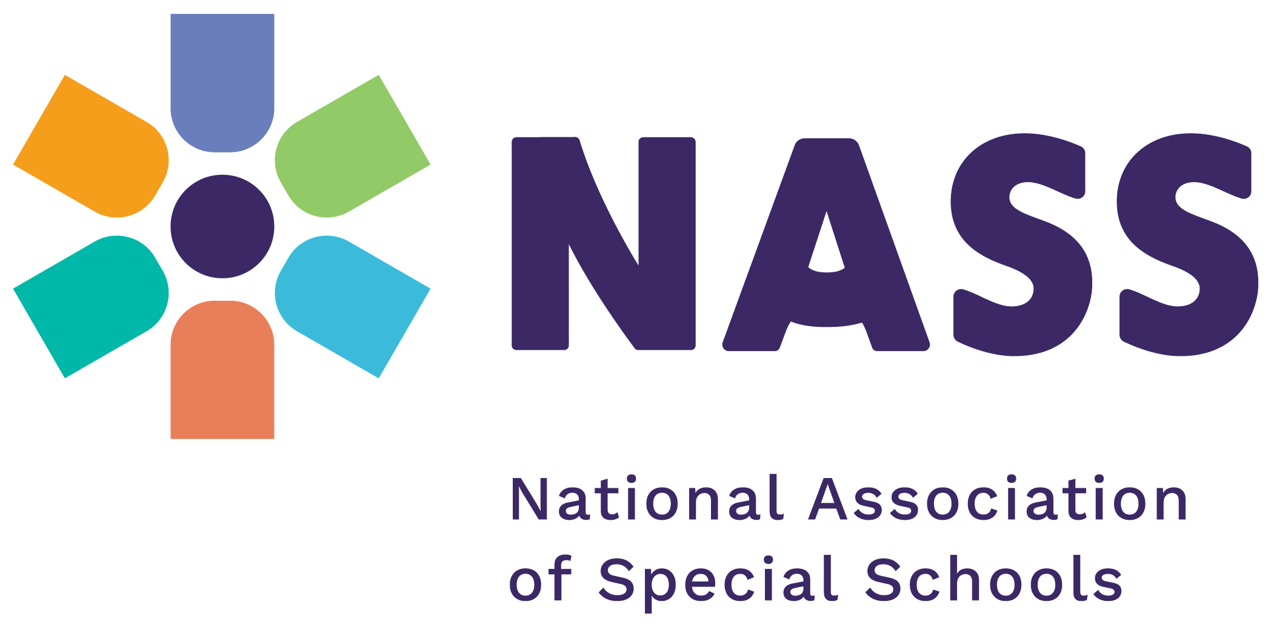

NASS Leadership Development Programme 2025
APPLICATION FORM
PROGRAMME COST - £1200 per delegate
First Event Day: Tuesday 14th January 2025
Crowne Plaza Hotel, 61 Homer Road, Solihull,
West Midlands, B91 3QD
To apply for a NASS-sponsored place, please read the booking terms and conditions on page 3 prior to completing the application form.
Deadline for receipt of booking 5.00 P.M. on Wednesday 23rd October 2024

School/Organisation Name & Address (including postcode):
Applicant’s Name:
Applicant’s Job Title:
Applicant’s Tel:
Applicant’s Email:
Do you have any special requirements? (e.g. dietary, access, communication etc) please give details

Successful applicants will be notified via email on or before 4th November, so please remember to include the applicant’s email address.

What are you hoping to get out of participating in the ‘Leadership Development’ programme?

What areas of leadership are you hoping to consider as your project within the programme? We will not hold you to this but want to get a sense of where you might focus your attention within school.

NASS Leadership Development Programme 2025
CONDITIONS OF APPLICATION
This event is only available to NASS members. The price of this programme is subsidised by NASS and is subject to the programme’s terms and conditions including the cancellation policy.
Terms & Conditions
- The programme fee is non-refundable
- The programme is not accredited and does not result in a formal leadership qualification
- Applications will only be accepted on receipt of a fully completed application form.
- Application forms will not be accepted without a signature.
- Signature, either electronic, typed or handwritten, constitutes acceptance of these terms and conditions including the cancellation policy.
- The workshop days require a full day’s time commitment – 10.00 a.m. – 5:00 p.m.
- Delegates are expected to attend all 6 workshop days. Please ensure you can be released from school to attend before applying.
- Delegates must make travel arrangements to accommodate the full day’s time commitment specified above.
- A travel bursary is available for charitable and small schools. Please note when applying if you would like to be considered for this.
- Successful schools agree to support a workshop on the Leadership Programme at the 2025 NASS annual conference, either through attending or providing video or other media input.

Cancellation / Non-Attendance / Failure to Complete Full Programme Policy
- An additional £800 fee applies should successful applicants cancel their booking, not attend or fail to complete the full programme.
- Invoices will be issued in respect of cancellation/non-attendance/failure to complete the full programme to contribute towards the cost of the subsidy.
- Any cancellations must be confirmed in writing by email or letter.

Declaration
I have read and agree to the application terms and conditions, including the cancellation/non-attendance/failure to complete full programme policy.
If my school is successful I agree to pay the programme fee of £1200 per delegate and understand this is non-refundable.
I understand that should my school cancel, not attend or fail to complete the programme we will be invoiced for a further £800 to contribute towards the cost of the subsidy.
Name:
Signature* Date
*Signature, either electronic, typed or handwritten, constitutes acceptance of the terms and conditions, including cancellation policy shown above. Forms will not be accepted without a signature.

Please send your completed application form to Claire Dorer cdorer@nasschools.org.uk to be received no later than 5.00 p.m. on Wednesday 23rd October 2024.

